Highlight Specific Cells using Conditional Formatting

Highlight Specific Cells below, above or equal a certain number.
Imagine you have a Stock List that when the number reaches a certain level it is time to reorder. There are many options you can use and Conditional Formatting is one them.
In this example we have four columns Date, Amount, Sold and Remaining.
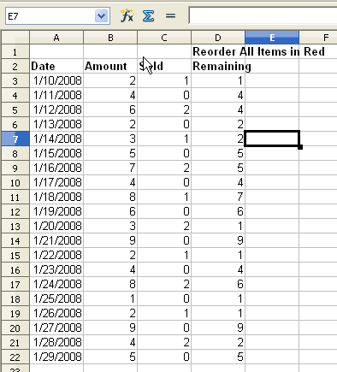
We want the Remaining column to show cells as red when they reach a certain level.
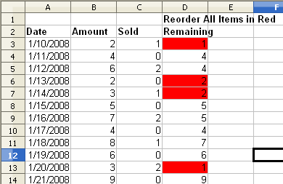
The simplest way to do this is to highlight the cells you want to show as red when they reach 2 or below. Go to the Format menu and select Conditional Formatting.
This will open the Conditional Formatting dialog box
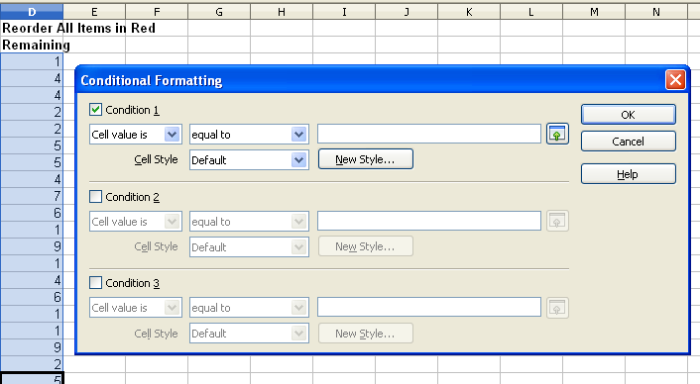
Use the Cell Value is option and select from the drop down list "less than or equal to" then the number you wish to order at, in our case it will be 2.
Select the New Style button and change to the Background tab. Select light red (or your color of choice) and click on OK.
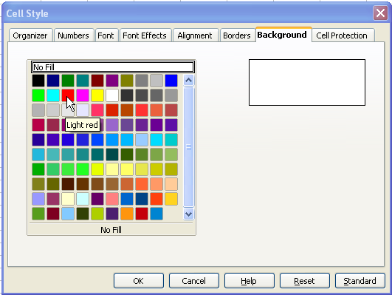
You will be returned to the Condi tional Formatting box.
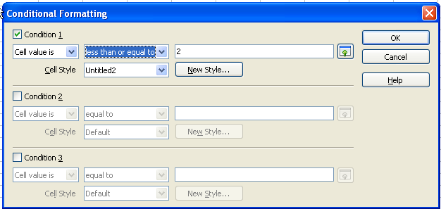

Your table will now show all the items that you need to reorder.


